Introduction

What is the difference between scary and creepy?

Cameron Leighton

Fear is an evolutionary response to stimuli that presents the potential for harm towards the living being. It is a specialised response inherited by our ancestors that were able to survive the harsh conditions of the wild and the world; in which their ability to feel fear granted them the tools to adapt to their environment and protect themselves from threats. Fear is made up of both neurons and brain structures genetically passed on, and the ability to add new information and associations between stimuli and physiological/psychological responses; to be better prepared to respond to the possible threat in the most desirable way, in terms of self-preservation and safety. However, due to the nature of fear and the processes within the brain, another psychological phenomenon is present within our psyche which is closely related to the purposes and feelings of a conventional fear response. This phenomenon has been given the name of “the creeps”; the uncanny valley. The feeling of unease and tension in an environment with an ambiguous nature. The purpose of this project is to explore the nature of this unusual psychological concept, and how it is psychologically, biologically, and physiologically similar and different to a standard fear response. I am going to look deeply into the nature of creepiness, the evolutionary explanations as to why we feel creeped out, what happens inside the brain to generate this feeling; and then create a comparative analysis of both creepiness and fear. I will use various websites and books to back up the claims made of possible explanations by researching neurological concepts of brain processes, and then link them to psychological concepts. Evidence from studies of different psychological concepts will be linked to fear and creepiness and reinforce my evaluations and claims. I will first discuss the purpose and importance of the autonomic nervous system (ANS) and the limbic system, and how they work simultaneously to produce a fear response in the individual, and physiologically prepare the body for a possible threat. Next, I will discuss concepts of classical conditioning and synaptic plasticity, and how the amygdala and the Autonomic Nervous System work in unison to allow a conditioned response to be produced, and how it allows the person to remember the feeling of fear they felt for a specific stimulus by associations. I will then move on to theories created to explain the feeling of creepiness, and back up the theories with studies and concepts produced that help explain the feeling. I will analyse two dominant theories: first, the pathogen avoidance hypothesis, and the Agency detection theory. The pathogen avoidance hypothesis asserts that features of an organism that would suggest possible disease produces the feeling of “the creeps” to preserve us and protect us from disease. The agency detection theory suggests our senses are heightened when we are in an environment that might have possible danger, leading to our brain preparing us for possible danger. Discussing both fear and creepiness will set the criteria for comparison to determine their differences.

What is scary: The Autonomic Nervous System

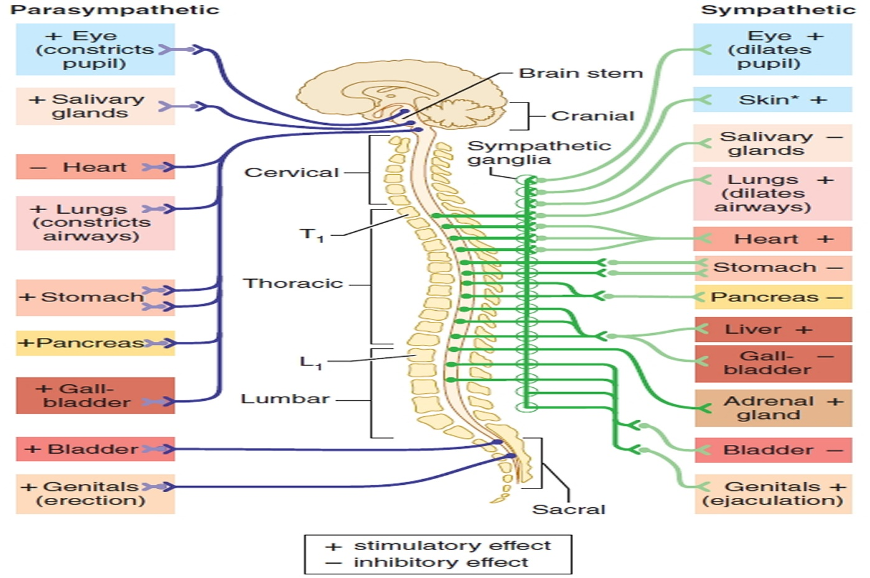In order to compare both the feeling of fear and the feeling of creepiness, groundworks need to be set; how fear works within our body, in which fearful things are picked up from our brain and sent to our body to allow the emotion of fear to be accompanied by physiological changes. When the unconscious mechanisms of fear are explained, and why it works the way it does, we can see the similarities and differences between being scared and being creeped out; and what the purpose of fear is.

Fig 1: The autonomic nervous system

Fearful stimulus is picked up from our amygdala, in which it is sent to out hypothalamus, which acts as a command centre. Once the amygdala has sent the signals to the hypothalamus, distress signals are sent to the sympathetic/parasympathetic divisions within the autonomic nervous system (Harvard Health Publishing: Understanding the stress response. 2011). The action potentials from the brain are sent down the neuronal axons, down the spinal cord and preganglionic neuronal axons, where those signals are sent to their ganglia. Between the synapses inside the ganglia, a neurotransmitter is sent through the nerve fibres called acetylcholine. If the action potentials are strong enough, it will send the neurotransmitter to the post ganglionic fibres to its effector organs (Green, 2015). Purves, (2007) suggests that the sympathetic division of the autonomic nervous system is responsible for stimulating specific muscles by sending more blood to those organs, whilst inhibiting the blood supply of other organs; for example, the thoracic spinal cord segment accelerates the heartrate, whilst also inhibiting digestion in the stomach. The parasympathetic division does the exact opposite of the sympathetic division, in which it stimulates the organs that the sympathetic division would attempt to inhibit and inhibit the organs that the sympathetic division would attempt to stimulate. For example, the cranial segment slows down the heartbeat and stimulated digestion. As suggested by Purves, (2007), giving muscle instructions to subjects in making a facial expression without telling will end up being “accompanied by specific and reproducible differences in visceral muscle activity”. A study by Gaskell & Langley (1866) showed the neural control and visceral functions of the Autonomic Nervous System. They discovered this by stimulating the upper thoracic spinal segment of the sympathetic nervous system, in which the animal’s heartbeat accelerated in response. Gaskell (1866) concluded that “every tissue is innervated by two sets of nerve fibres of opposite characters” and further surmised that these actions showed: “the characteristic signs of opposite chemical processes”. This study shows the accompaniment of the feeling of fear and the physiological changes that our bodies go through when a fearful stimulus is presented to us. The feeling of fear is felt by the emotional expression from the limbic system.

The Limbic System

Papez, (1937) proposed that the specific brain circuits in the limbic system are devoted to emotional experience and expression, in which he explored the medial aspects of the cerebral hemisphere. The forebrain circuit for control for emotional expression has been revised to include parts of the orbital and medial prefrontal cortex, ventral parts of the basal ganglia, the medio dorsal nucleus of the thalamus, and a large nuclear mass in the temporal lobe anterior to the hippocampus called the amygdala. The amygdala is shown to allow for fearful stimuli to be picked up by the animal in order to make sense of the stimuli in front of them, and to send a distress signal to the hypothalamus, and finally to the Autonomic Nervous System. The amygdala is an essential section of the limbic system in the expression of emotion, especially the expression of the feeling of fear.

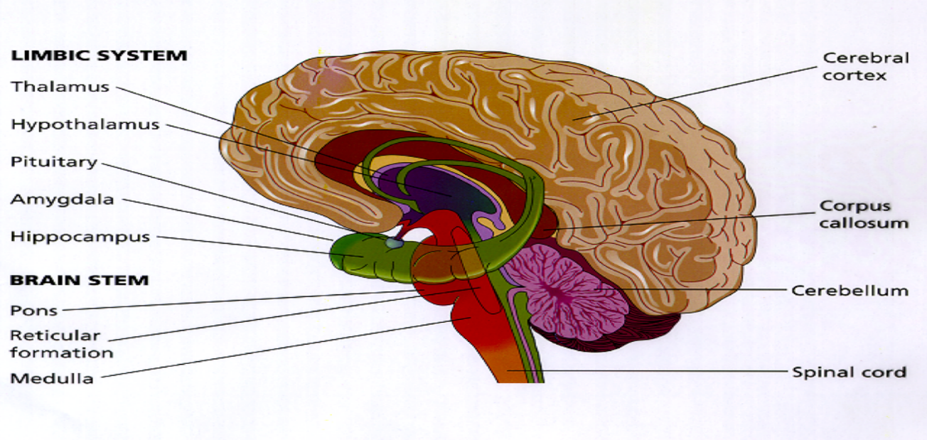Fig 2: The limbic system

Kluver & Bucy, (1937) are known for their work on behavioural disorders, in which they discovered a disorder caused by damage to the amygdala in the medial temporal lobe, named “Kluver-Bucy syndrome”; in which the damage caused to the medial temporal lobe inhibits the organism’s emotional expression of fear, as the amygdala can no longer send a distress signal by observing stimulus that would exhibit a conventional fear response. They conducted an experiment on rhesus monkeys by removing a large part of their medial temporal lobe. Before they removed the medial temporal lobe, the monkeys would show a fear response towards stimulus such as snakes and the doctors. However, once the amygdala was damaged, the monkeys stopped showing fear towards things that would normally elicit a fear response; they started showing “kluver-Bucy” symptom traits. This study demonstrates the significance of the amygdala in the feeling of fear and exhibition of emotional expression, as without it, the rhesus monkeys could not show fear through physiological nor emotional changes.

Both the accompaniment of the physiological changes of stimulation and inhibition of effector organs by the autonomic nervous system, and the emotional expression from the medial temporal lobe allowing physiological expression by the distress signals sent to the hypothalamus in order to reach the ANS can show the importance of fear. The strengthening of muscles and the fear response shows that fear is an important defence mechanism for survival for organisms, with the sympathetic division preparing the organism’s body to either fight off the predator by sending blood to the arm muscles, or to run away by sending blood to the leg muscles. As Canon, (1871) suggested that the “intense activity of the sympathetic division of the visceral motor system prepares the animal to fully utilize metabolic and other resources in challenging or threatening situations”, (Purves, 2007). Without the interpretation of fearful stimulus from the amygdala, the animal would not react to the possible danger, which would most likely end up inhibiting the animal’s chance of surviving. Fear would not have a purpose without the “quickened heartbeats nor of shallow breathing”, (James, 1893).

Classical Conditioning

Another important feature of fear response, in terms of explaining how the full process works and its purpose for organisms, is the concept of memory, specifically, learning the associations between stimulus and the outcome of the event accompanied with an emotional/physiological response. Concepts that will be discussed in this chapter are classical conditioning and synaptic plasticity. Discussing concepts with evidence from studies will allow for another comparison of the similarities and differences between the feeling of fear and the feeling of creepiness. Classical conditioning is the psychological explanation for how we associate an object, person, or stimulus with an emotional/physiological response, in which the first stage is that the “unconditioned stimulus (UCS) produces an unconditioned response (UCR) in an organism.”. Describing the responses to stimulus that were not conditioned are natural responses. The second stage is that the: “stimulus which produces no response (i.e., neutral) is associated with the unconditioned stimulus at which point it now becomes known as the conditioned stimulus (CS).” The final stage, after the conditioning of the stimulus and the emotional/physiological response has happened: “the conditioned stimulus (CS) has been associated with the unconditioned stimulus (UCS) to create a new conditioned response (CR)”, (McLeod, 2018). This concept can explain anxiety disorders such as phobias, as with the logic of classical conditioning, a child experiencing a traumatic event with a spider will cause the child to associate the feeling of fear that he felt during the traumatic experience with the spider where the presence of the spider, or simply mentioning the spider, can elicit the same emotional and physiological response the child had towards the initial attack, as he has made an association between the spider and the emotional/physiological response that the spider gave him, thus causing arachnophobia. A famous study that supports classical conditioning and was the founder of this psychological phenomenon was Pavlov’s dogs’ study by Pavlov (1936). During Pavlov’s study on digestion on dogs, he noticed the dogs began to salivate when the scientists came into the room. He hypothesised that the dogs associated the scientists with food, as they would usually come in to feed the dogs. He conducted a study in which he rang a bell at the same time when he would feed the dogs, whether to see if the dogs, after repeating the process of ringing the bell when food is given to them, they would salivate to the sound of the bell, even without the showing of food. Even without the bell: “It was then seen that the dog still continued to salivate at the sound of the bell, expecting the presentation of food” (Shrestha, 2017). Due to the amygdala’s role in sending the distress signal to the hypothalamus in order to elicit a physiological response, the amygdala plays an important role in the associations between stimulus and responses. The amygdala is able to make these associations due to the neurological concept of synaptic plasticity.

Synaptic Plasticity

In terms of the structures of the brain, synaptic transmissions are the main form of circuitry throughout the brain, allowing neurons to communicate and send signals to each other by sending neurotransmitters. The same synapses go through a process called “synaptic plasticity”. Synaptic plasticity is the modification of the activity between two neurons, where their activity is either strengthened by firing together, meaning the “connection between these neurons is potentiated” (Shouval, 2007), making it more likely for those neurons to fire together more quickly.

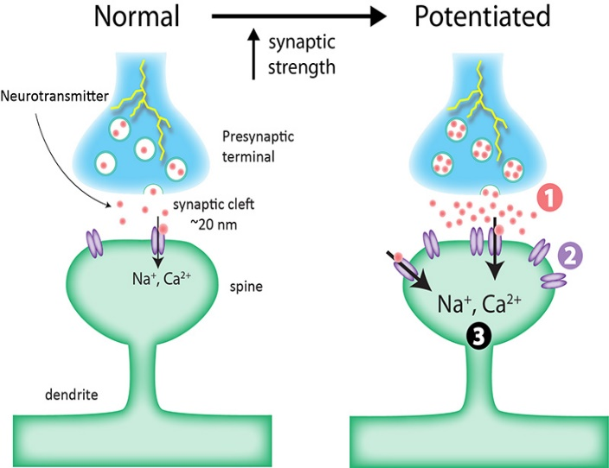

Fig 3: Synaptic potentiation

This process is called long term potentiation. Short term synaptic plasticity includes two processes: synaptic facilitation, which is an increase in synaptic strength that occurs when “two or more action potentials invade the presynaptic terminal within a few milliseconds of each other” (Purves, 2007); and short-term depression, meaning a decline in synaptic activity from a sustained number of neurotransmitters being released from the synaptic clefs. The potentiation of two neurons is what allows classical conditioning to take place, as the neurons inside the amygdala strengthen when it associates the perceived stimulus with both the emotional expression of fear, and the physiological changes of the body, causing the association to be more prominent and to more likely be remembered in the future. Linking back to the Autonomic Nervous System, the depression of synaptic strength from constant neurotransmitter activity has to happen. The research undertaken on the inhibition of blood supply in certain organs shows the possible danger of constant activity in the sympathetic division, as it may lead to damage in organs if deprived of oxygen and blood for a duration of time. The depression of synaptic strength of associations allows for a decrease in emotional and physiological expression in order to preserve energy. This is how the anxiety disorder treatment called “flooding” works, in which the sympathetic division is stimulated for a period of time from an associated stimulus, where the individual has: “prolonged exposure to the actual stimulus that provoked the original trauma” (Psychologist world, Flooding), causing the synaptic strength to depress.

Learning is an incredibly important factor in terms of a fear response in that the organism can remember the associations and the responses they learned from pairing the response that came from the event with the stimulus. From the research and studies I have found about associations and classical conditioning, it is evident that associating stimulus with responses is important as it allows vigilance within the organism; as the organism, through the evidence of Pavlov’s study, will learn the stimulus to stay away from in order to survive by pairing that stimulus with the emotional and physiological response that was exhibited. The genes of the organisms that have associated with strongly paired neurons will be more likely to pass on their genes and have the next generation of organisms be as prepared for danger as they were.

Why do we feel creepiness: Pathogen avoidance hypothesis & Agency detection theory

Whilst being similar to the feeling of fear, the feeling of creepiness is demonstrably different in terms of how we cognitively and physiologically respond.

The reason why we feel creepiness towards external stimuli, rather than a full conventional fear response is also considered here. The two theories that are going to be the main focus of this section to explain the purpose of creepiness is the pathogen avoidance hypothesis and the agency detection theory, with both theories supported by research.

The Pathogen avoidance hypothesis suggests that the feeling of creepiness towards a stimulus is caused by our brain believing the stimulus to be ridden with disease, and therefore, for self-preservation, elicits the sensation we call creepiness in order to warn us of the potential for disease. MacDorman et al., (2009) argues that: “the uncanny feeling is rooted in the basic emotion of disgust.” This theory of the feeling of creepiness leads to the phenomenon called the “uncanny valley”, which was founded by a Japanese roboticist named Masahiro Mori, where he discovered that a rising level of human likeness in a robot will raise the individual’s affinity towards it. However, at a certain point, the level of human likeness in the robot or human figure will cause a sudden drop in affinity, meaning the level of human likeness emphasises the features of the stimulus that is distorted. This phenomenon can explain why some people find dolls creepy, as they would fall into the uncanny valley, due to its detailed human features, yet its non-human likeness causes a drop in comfortability towards it, (Mori, 1970).

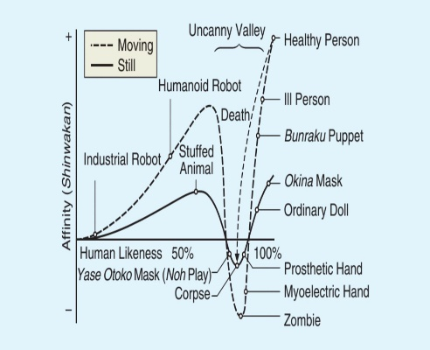

Fig 4: The uncanny valley chart

The pathogen avoidance hypothesis links to this phenomenon as the human likeness of the stimulus relates to what we know, but the features that deviate from conventional human characteristics causes a drop in affinity as it is not what we are used to, and therefore, we will perceive dolls and mannequins, unconsciously, as having possible diseases on them.

Another theory in explaining the feeling of creepiness is the agency detection theory. This theory suggests that the uncertainty and the ambiguity of a situation and the environment the individual is in can cause a feeling of uncomfortableness, in order to keep us on our toes just in case there is danger in their environment; our senses are heightened in ambiguous uncertain situations in order to prepare us for possible danger and threats to our wellbeing. A study by McAndrew & Koehnke, (2016) attempted to decipher what the general population perceives as creepy, by focusing on concepts of ambiguity and uncertainty, especially in terms of what is socially acceptable and expected. The researchers created a Facebook survey (quantitative study) on which features of an individual they find the creepiest and the most unnerving, for example: physical features. The results showed that the perceived creepiest physical features of an individual were:

* The person was dressed oddly (.601),
* The person had greasy hair (.582),
* The person had unkempt hair (.609).

Results also showed that the occupations perceived as the “most creepy” were Clown and Taxidermist. The physical features that were the creepiest among the individuals supports the idea of the agency detection theory as they are features that may imply ambiguity and uncertainty, as the features shown were not socially acceptable or expected. The breaking of social intercourse from jobs such as the clown supports the theory as it causes uncertainty of the intentions and the true facial expressions of the individual, which is what is usually relied on through social interactions due to the covering of the face, which is not part of traditional social norms. The breaking of social norms causes uncertainty as it is not what the individuals are used to. The study supports the idea that the agency detection is activated by situations of uncertainty. The uncertainty arises from situations that are different to our socially constructed expectations. Due to the organism not being familiar with what is happening, it must stay vigilant, just in case.

A comparison between scary and creepy

From the above explanations of the purposes of both fear and creepiness, we can now discuss the similarities and differences between both psychological concepts. Creepiness can now be physiologically and biologically explained through the foundations of explaining how the feeling of fear works. In terms of both of their purposes, we can see that fear is used in order to prepare the organism for the potential of a threatening stimulus and threatening situations that they might experience in the moment, by preparing the organism to utilize their energy in the most efficient way in order to either fight off the threat, or to run away from said threat. However, the purpose of feeling creepiness is to prepare the body and mind for possible danger that might happen due to the uncertainty of the situation, so therefore, prepares the organism for a possible fear response that they might need. Situations and stimulus that deviate from strong neural connections we have made for what we have learned and what we are used to cannot elicit a conventional fear response. Long term potentiation for the physiological response of fear has not been connected with possible danger in which there is no physical harm towards the organism. No neural pathways to fear will elicit a fear response. The stimuli that elicit a response of creepiness is a response to ambiguity; in which it is not clear as to whether possible physical harm may come upon the organism. Situations with ambiguity have been associated with possible danger, as it deviates from neural pathways and existing schemata that the organism is used to and is able to use what the organism has learned to quickly respond to stimulus. When the threat is clear, a clear fear response can be elicited. The clear danger in our primal days allowed for strong confident neural connections that were able to pass down from generation to generation, with the thanks of the accompaniment of the emotional expression of the amygdala and the physiological expression from the excitement of muscles from the Autonomic Nervous System. However, for things considered creepy, the fear response would come after those interactions considered creepy, as they were associated with the preparation of possible danger. This is supported by the pathogen avoidance hypothesis as the distorted features of a human is considered creepy, as the distortion contravenes the expected typical human form. This would imply that there is a possibility that the organism is dangerous, as it is not what we are used to and have associated with safety. The distortions of the human-looking organism to the brain, would imply possible danger, and thus prepares us by causing a feeling of disgust. The agency detection theory supports the idea that the difference between the feeling of fear and creepiness is that they are both preparations for different circumstances as the features of a human that were considered creepy were the features that go against social norms and what we are used to seeing on a human face; the distortions cause ambiguity, due to the lack of familiarity towards the distorted humanoid figures.

Literature review

The sources for the discussion of the Autonomic Nervous System were useful in gathering information on the specific areas of the system, and for doing within the body; studies I have focused on illustrating the knowledge of the autonomic nervous system supports the validity of the claim of my extended project. (Harvard Health Publishing: Understanding the stress response. 2011) was an especially useful source for gathering content on the Autonomic Nervous System as Harvard studies generally increase the validity of the content when published in high-ranking journals with high impact factors. However, my source was made in 2011, since when new discoveries could have been made, decreasing the usefulness of the source, as it is potentially outdated. Green, (2015)was useful as it is a more recent source on the autonomic nervous system, which may increase the validity of the claims The YouTube video was highly detailed and allowed me to gather up a lot of information; as well as it being a highly respected education channel on YouTube, especially for the scientific field. Purves, (2007)was also useful. This source has an enormous amount of information on all the scientific concepts discussed in this extended project, including the Autonomic Nervous System, the limbic system and synaptic plasticity, which has increased the reliability of the application of the source within my extended project. The fact that Purves is in its 4th edition illustrates the information has been updated multiple times, increasing the robustness of the information.

However, it was written in 2005, marginally decreasing the validity of the information used in the source, as the information might be outdated due to new discoveries. Another weakness of using this source is its lack of cost efficiency, as it is an expensive book, though, I was able to circumvent this through this source being given to me. Gaskell & Langley, (1866) were a useful source to use. Their study allowed my research to be more efficient, leading to a more reliably and valid study; their study found a correlation between salient functions and the autonomic nervous system through the use of standardised procedures within their research. Papez, (1937) was a useful source as it acted as the foundations of the limbic system, allowing a general overview of the limbic system’s purpose to be illustrated, whilst being supported by the researcher. This allowed a further reinforcement of my claims in my extended project. Kluver & Bucy, (1937) was useful in terms of establishing the role of the amygdala in a fear response. This allowed my extended project’s main claim to be supported as a focus of the extended project is the role of the amygdala, which, allows my extended project’s main focus to be scientifically credited. The validity of the study is exhibited through the scientific procedures, leading to a finding of a cause and effect of the removal of the amygdala and the fear response. Canon, (1871) was not particularly useful as a source, as there was no valid data that supported his claims. The same weakness applies to James (1893). McLeod, (2018) was a useful source in gathering information about classical conditioning; the source was written by an individual with a doctorate, increasing the legitimacy of the information used. It is a more recent source, so the information is newer than most of my sources, allowing for a range of classic information and newer contemporary information. Shrestha, (2017) strengthens the existing information on classical conditioning that the extended project has given. Though the source is from 2017, the study it is referring to is from the 1890’s. However, Pavlov’s dog experiment increases my claims on classical conditioning, as it was the founder of the phenomenon, allowing me to get the original findings on this phenomenon by the origins. Shouval, (2007)was useful in terms of gathering information on synaptic plasticity. The website was useful as it is written by experts in their specific field. (Psychologist world, Flooding) was useful in terms of backing up my claims on synaptic plasticity, in which it focuses on how potentiation and depression works within the neurons; however, the fact that it is a website decreases its usefulness, due to the possibility of the author not being experiences enough in the field. Another strength of this source is its application to society and the real world, as it suggests a possible treatment for mental disorders using neurological concepts such as synaptic plasticity, allowing my extended project to be supported by real life applications. Moving on to the sources used to support the phenomenon of *the creeps* discussed in my extended project, Wang, et al., (2015) was a great insight into many different theories for the feeling of creepiness. The sheer quantity of theories used reinforces the credibility and reliability of using this source, as it gave me many options to discuss and made it easier to review. However, the reliability of using theories towards this phenomenon is decreased due to the extraordinarily few studies and theories made overall, as this phenomenon has not had a lot of attention in the field of psychology. However, a strength of this is that all my theories and studies are recent, causing the sources to more applicable and accurate to modern society. Mori, (1970) was a useful source in discussing and reinforcing a theory towards the feeling of the creeps. The use of a flow chart allows for a more objective and scientific perspective on this topic. McAndrew & Koehnke, (2016)was a useful source as it is a modern study, showing it is the most up to date ideas on creepiness. The source reinforced the topic of ambiguity, and applied it to the real world, in which objective data were used in order to see a correlation between the variables. This adds scientific validity and credibility towards my extended project. However, a weakness of this study is that it used a Facebook survey, in which people might have lied in their results, decreasing the usefulness of the study’s results.

Conclusion

The feeling of fear and creepiness both have an equal part to play in the survival of our species. Though they are quite different biologically, physiologically, and psychologically, they both serve a similar purpose: both are a response to things in the world that are a threat to our physical and mental wellbeing. It has been demonstrated here that the difference between scary and creepy is that fear is used during the fight for survival, and creepiness is used before the fight, as a pre-emptive cognitive strike to precipitate fight or flight.

What we do not know about the world makes us feel uneasy, we do not know what is ahead of us. To tackle what we do not know, our brain evolved to make us scared of it, or at least apprehensive! “The oldest and strongest emotion of mankind is fear, and the oldest and strongest kind of fear is fear of the unknown.” (Lovecraft, 1927)

References

* Dale Purves (2007), 4th edition, Neuroscience, pg. 178, 517, 733
* (Dr. Saul McLeod 2018, Simply Psychology, Classical Conditioning).
* Francis T. McAndrew\* & Sara S. Koehnke (2016), “On the nature of creepiness”
* Green, H, (2015), Sympathetic Nervous System: Crash Course A&P #14 - Youtube
* (Harel Z. Shouval, 2007, Scholarpedia, 2(7):1605.),
* (Harvard Health Publishing: Understanding the stress response. 2011).
* Heinrich Kluver & Paul Bucy (1937),
* Ivan Pavlov (1936).
* James Papez (1937)
* Masahiro mori, (1970), A valley in one’s sense of affinity.
* (Praveen Shrestha 2017, Psychestudy, Pavlov Classical Conditioning).
* P. Lovecraft Quotes About Fear and Horror #1.
* (Psychologist world, Flooding),
* Shensheng Wang, Scott O. Lilienfeld, and Philippe Rochat, 2015, “The Uncanny Valley: existence & explanations.”
* Walter Canon (1871)
* Walter Gaskell & John Langley (1866)
* William James (1893)

Figures:

* Fig 1: <https://healthjade.com/autonomic-neuropathy/>
* Fig 2: <https://www.chegg.com/flashcards/psychology-202-f3f9f2c4-48ed-43a7-902b-8187b78e0629/deck>
* Fig 3: <https://qbi.uq.edu.au/brain-basics/brain/brain-physiology/long-term-synaptic-plasticity>
* Fig 4: <https://spectrum.ieee.org/automaton/robotics/humanoids/the-uncanny-valley>